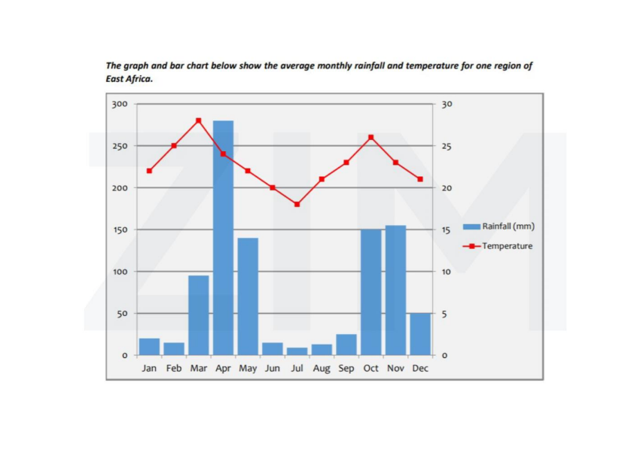

The depicted line chart illustrates the monthly rate of change in temperature, while the bar graph demonstrates the average precipitation over a period of one year in one region of East Africa.

Overall, the line chart highlights the substantial fluctuation trend in the temperature in East Africa, which March is recorded as the hottest month in a year, meanwhile the bar chart relatively follows this trajectory, in which the average monthly rainfall is proportional to the temperature.

Let’s take a closer look at the line chart for more details. Starting at 23 degrees in the first month of the period, the local temperature in East Africa then gradually rises to 27 degrees in the following two months, making it the peak figure among 12 months. Nevertheless, this level swiftly decreases to just 17 degrees in July and then remarkably recovers to over 25 degrees in a subsequent couple of months. Ultimately, it slightly becomes colder by the end of a period.

On the other hand, beginning at just a half of 50mm rainfall in January, the average precipitation shot up to over 10 times after 3 months, at 270mm in April. Subsequently, this area soon becomes drier in the following quarter of the year, plummeting to just nearly 20mm. Having experienced a notable recovery to over 150mm in November, the rainfall plunges to a third at the end of the course.